SASHWAT BHARDWAJ-UML ASSINGMENT

1.

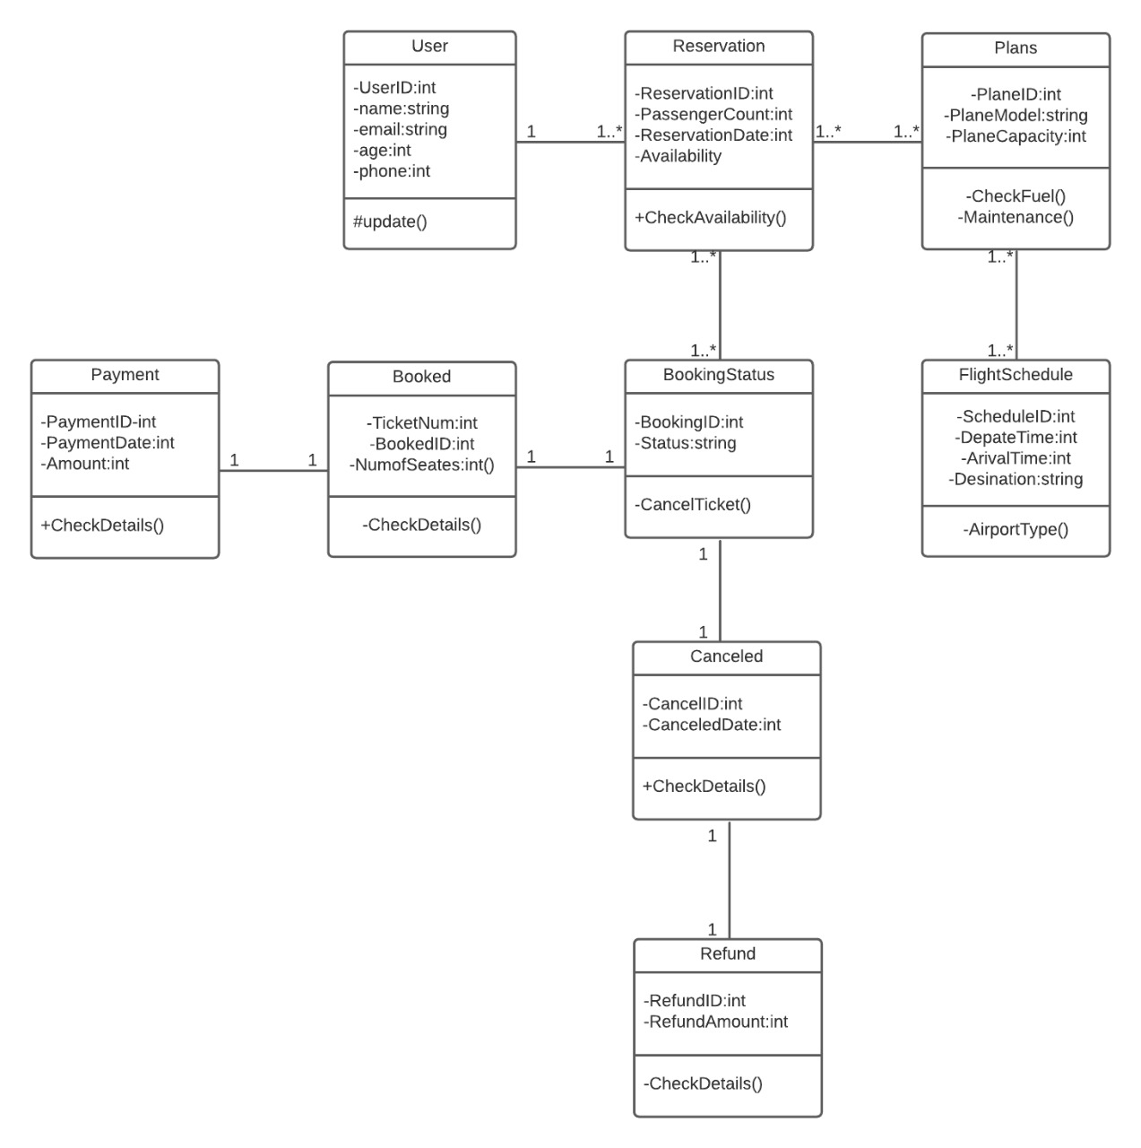

2.

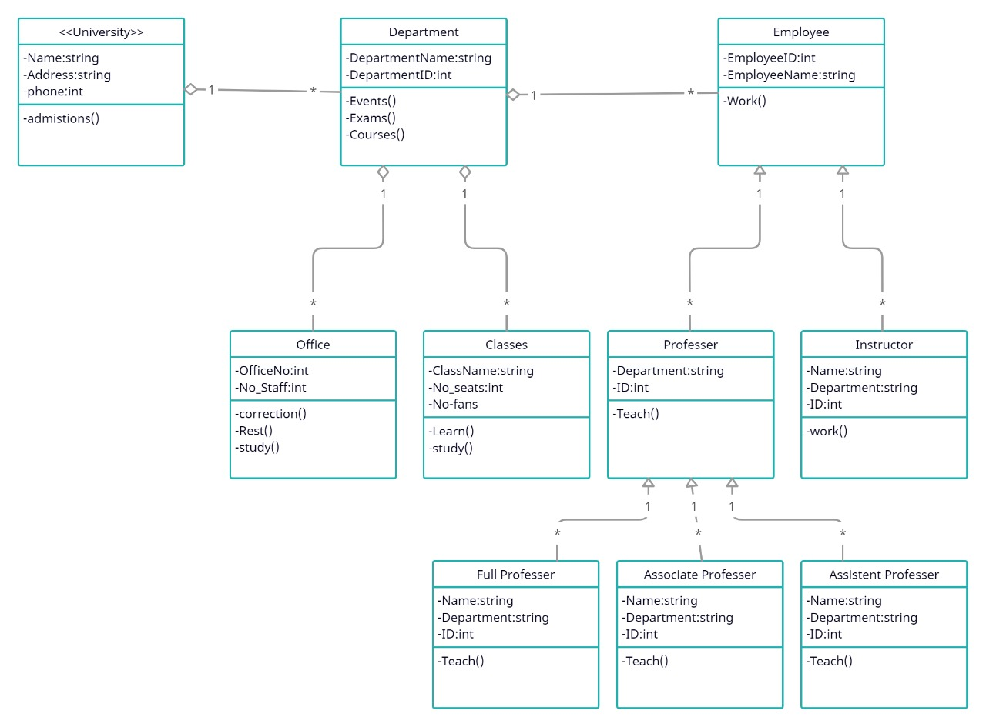

3.

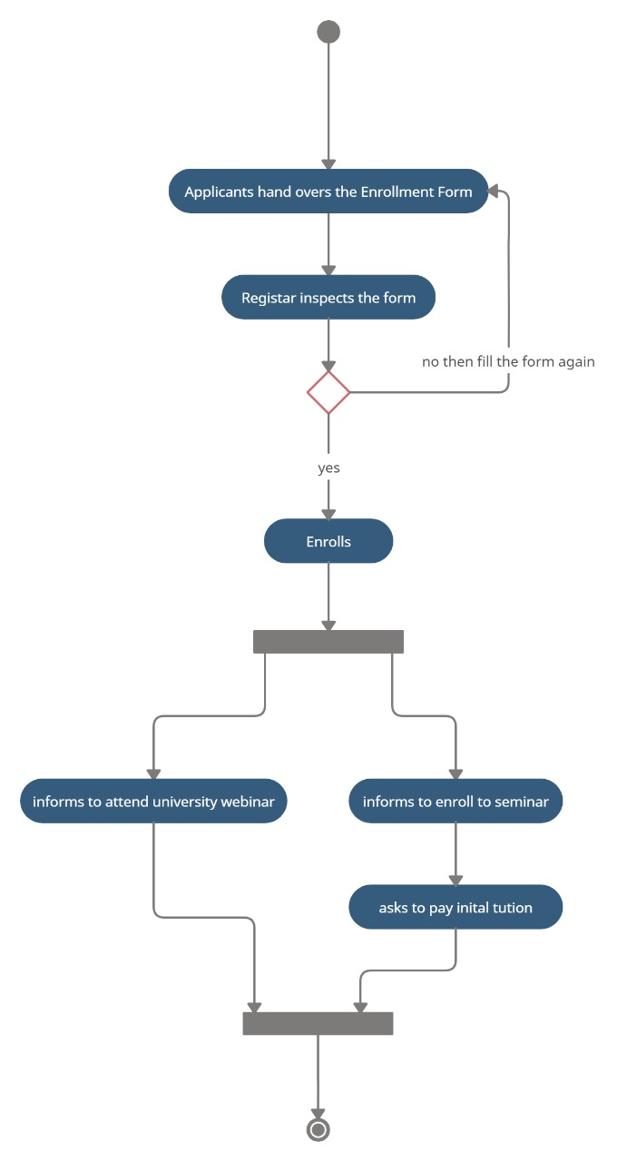

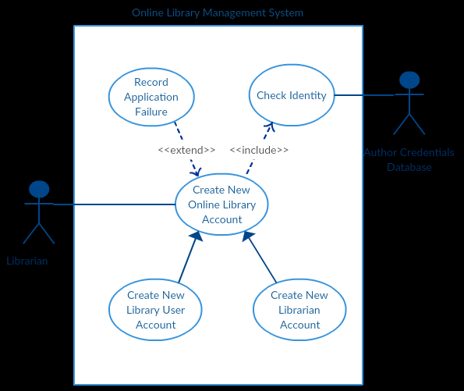4. A scenario of Online Library Management System is given below. You need to refer the use case diagram and moving further need to create a sequence diagram for the same.

Here are the steps that occur in the given use case named ‘Create New Library User Account’.

